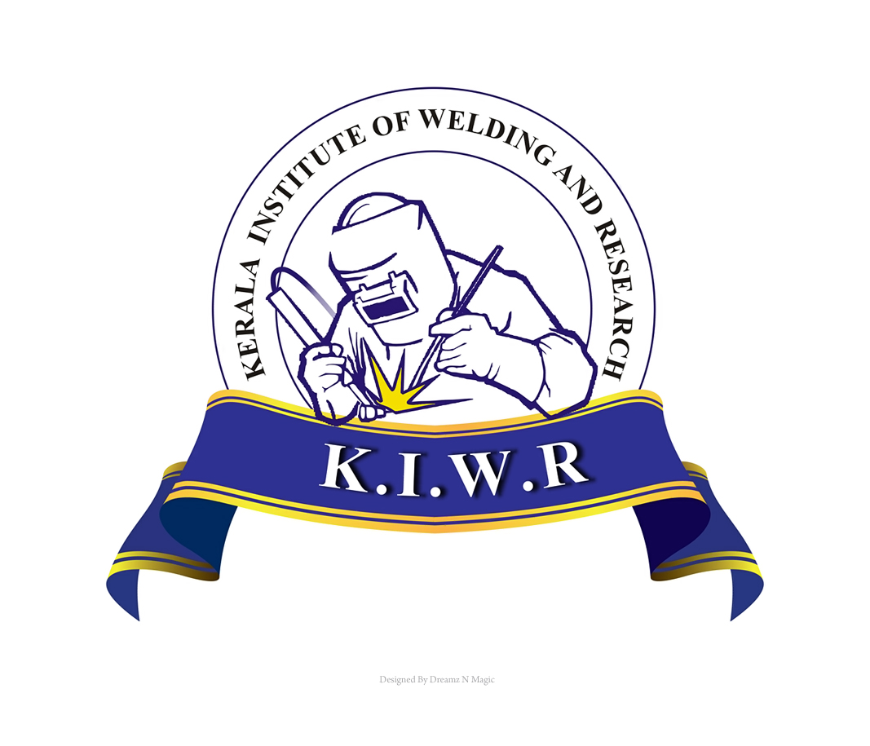
KERALA INSTITUTE OF WELDING AND RESEARCH (KIWR)
FACT TRAINING CENTRE CAMPUS
UDYOGAMANDAL – 683 501, ERNAKULAM DT., KERALA
Telephone : 0484 2556750, 0484 2546838 Fax: 0484 2546838
e-mail : director@kiwr.edu.in, mohanan@factltd.com

Director/KIWR/ 15-04-2014

WANTED OFFICE ASSISTANT

Kerala Institute of Welding and Research (KIWR), FACT Training Centre, Udyogamandal, Ernakulam invites application for the post of Office Assistant.

Requirements:
- Should be BCom holder with Computer literate and good in MS Office, Excel, Tally.
- Should have good command over spoken and written English language.
- Should be able to handle routine office work, accounts, record keeping, documentation.
- Should be self driven and dedicated to work.
- Should be below 30 years.

Application in the attached format with self attested copies of documents to prove address, age, qualification, experience etc. should reach on or before 30/04/2014.

Application should be complete in all respects. Incomplete, ineligible, belated application will be summarily rejected.

Application will be on contract basis for a period of one year which can be extended based on performance.

Institute reserves the right to reject an application or terminate the service at any time without assigning any reason.

Website: www.kiwr.edu.in Phone No. 0484 2546838, 2556750

Mohanan.I,
Director

